

**Lab-creating and managing Amazon EC2 Instance**

Entire document is divided into following sections :-

1. start with amazon Ec2.
2. How to select an Ec2 instance that suits your requirements.
3. Creating Ec2 instance and launching it.
4. Connecting to Ec2 instance .
5. Modifying the security settings of ec2 .
6. Extending the default root drive space of ec2 instance.

**start with amazon Ec2 :-**

Getting started with amazon ec2 is very simple . Go to **https://aws.amazon.com** and sign up for the amazon aws account .Login to amazon aws with your account credentials and open Aws Management console. Here you will find all the services your account has registered for .

 Click on ec2 and you will be redirected to the amazon ec2 dashboard that will look like below

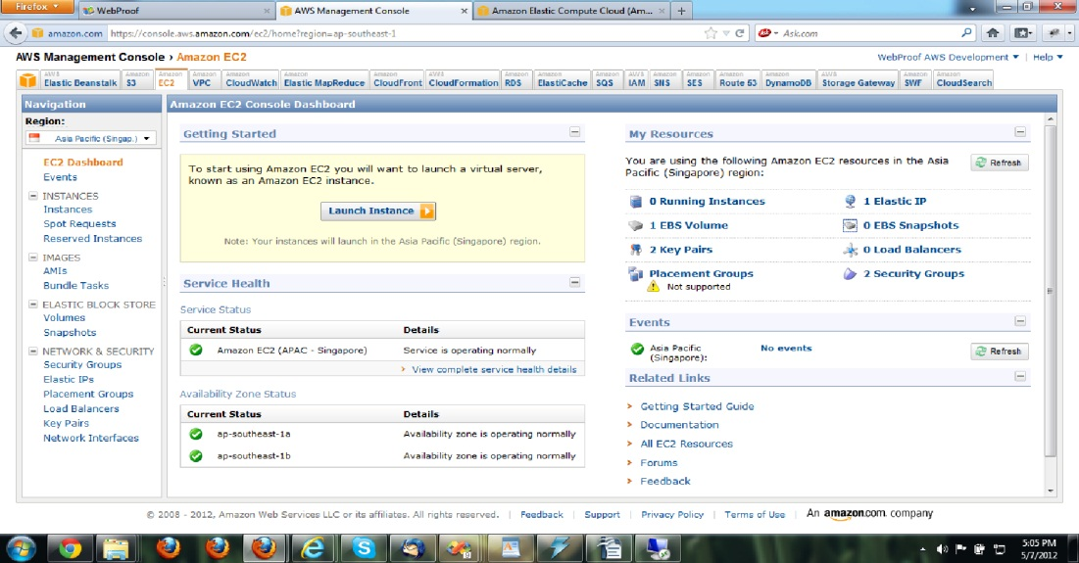

**How to select an Ec2 instance that suits your requirements :-**

On  Ec2 dashboard you will see a Launch Instance button that will let you create your own Ec2 instance in the amazon cloud .

Amazon basically provides four type of instances according to their size and computing capacity :- 1.  Small

                  2. Medium

                   3. Large

                   4. Extra large.

If you are going to build a development environment on the ec2 server then a small ec2 instance will be good enough for your computing requirements.

**Creating Ec2 instance and launching it :-**

To configure an Ec2 instance go to ec2 dashboard and click on launch instance  button.

            Now you will see  “ Create a New Instance” window similar to

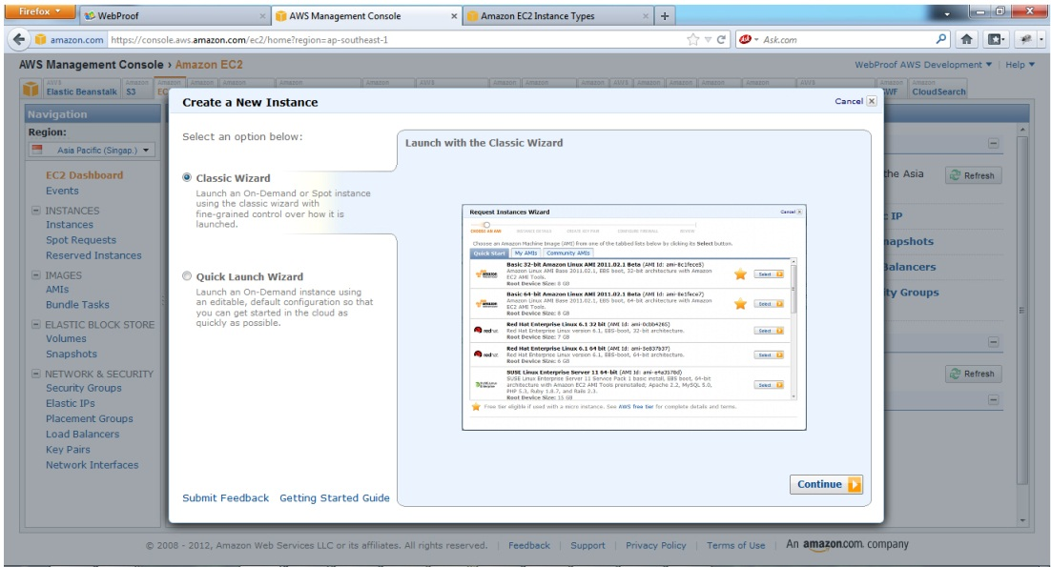

Here you will see two radio  buttons named classic wizard(selected default) and Quick launch wizard.

We need to create a customized instance as per our need so we will use classic wizard  .

Next  you need to click on continue button which opens up “Request Instance Wizard” window as follow :-

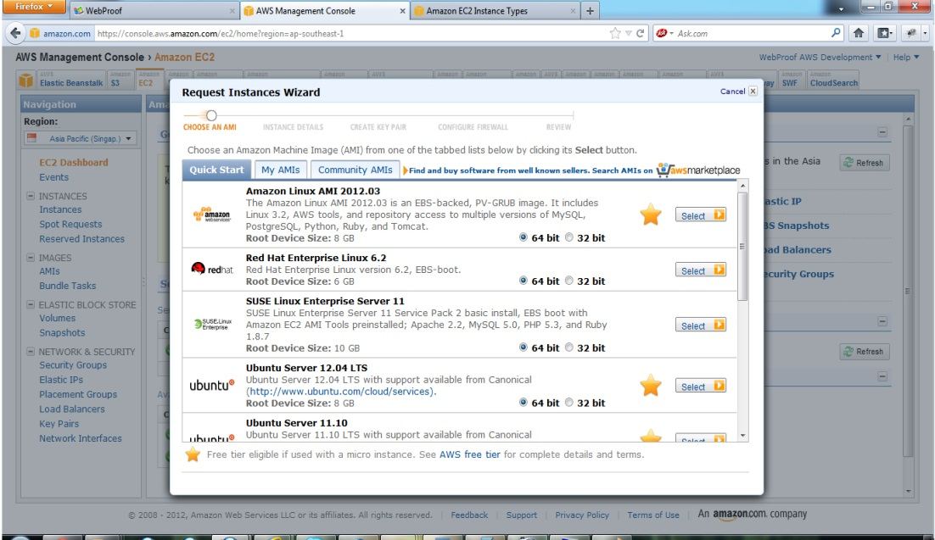

Select the appropriate combination of  OS/Applications and click select , you will get an option to chose the instance type(small/medium etc) and geographical region(Us/asia/europe)  where you would like your instance to run ..

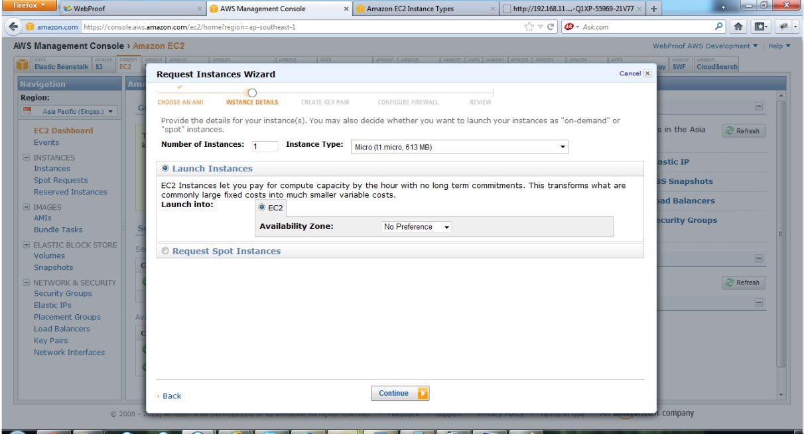

Here you will see two radio  buttons named classic wizard(selected default) and Quick launch wizard.

We need to create a customized instance as per our need so we will use classic wizard  .

Next  you need to click on continue button which opens up “Request Instance Wizard” window as follow :-

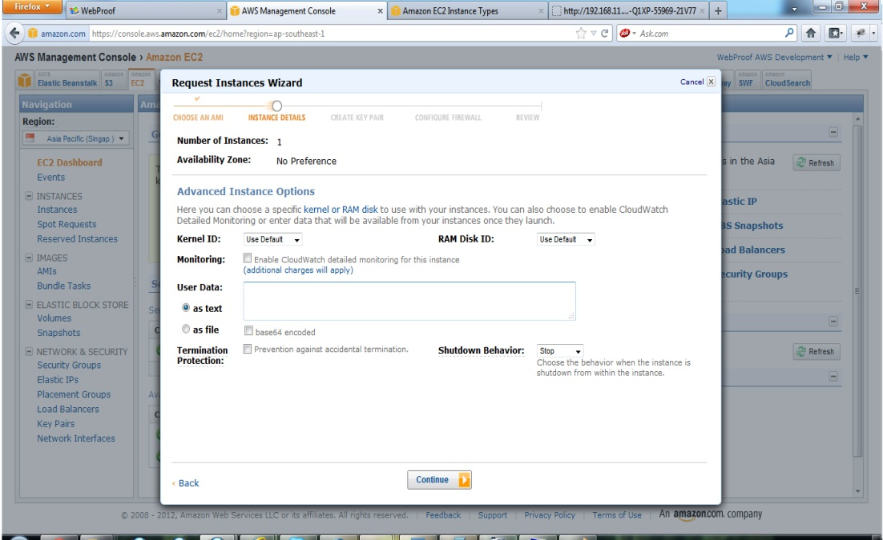

Select the appropriate combination of  OS/Applications and click select , you will get an option to chose the instance type(small/medium etc) and geographical region(Us/asia/europe)  where you would like your instance to run ..

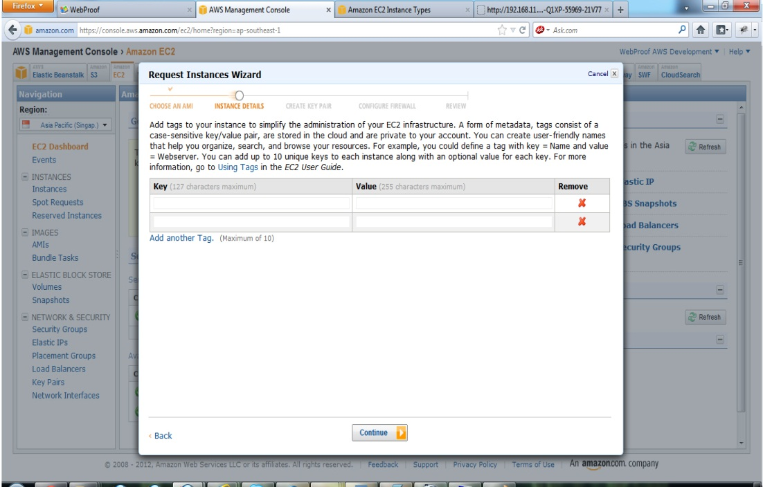

 You can leave it as it is and click on continue button  this will ask you to provide a tag as a combination of Key/value pair that will help you manage your Ec2 instances like search , organize etc.

Provide a key and value as you wish and click continue button.

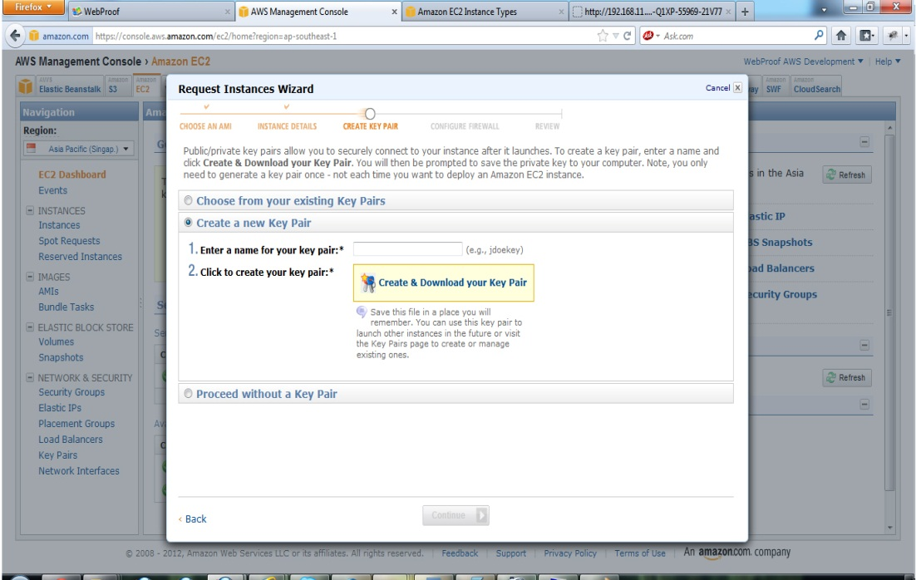

Click continue button that will opens up public/private key pair generation window :-

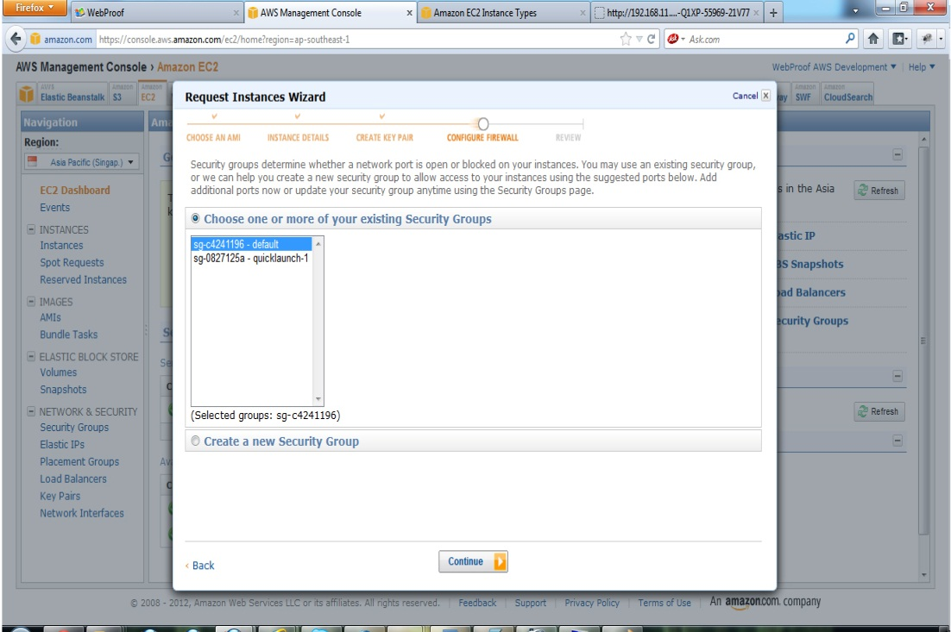

It will ask you to enter name of your key pair file and click on click on “Create and download key pair" button .

Allow download and save of this key pair file , this is very important file that let you  securely connect to your Ec2 instance once your launch is completed.

After you have done downloading and saving the file , click to continue button that will ask you to chose the

security group under which you would like to run your instance .

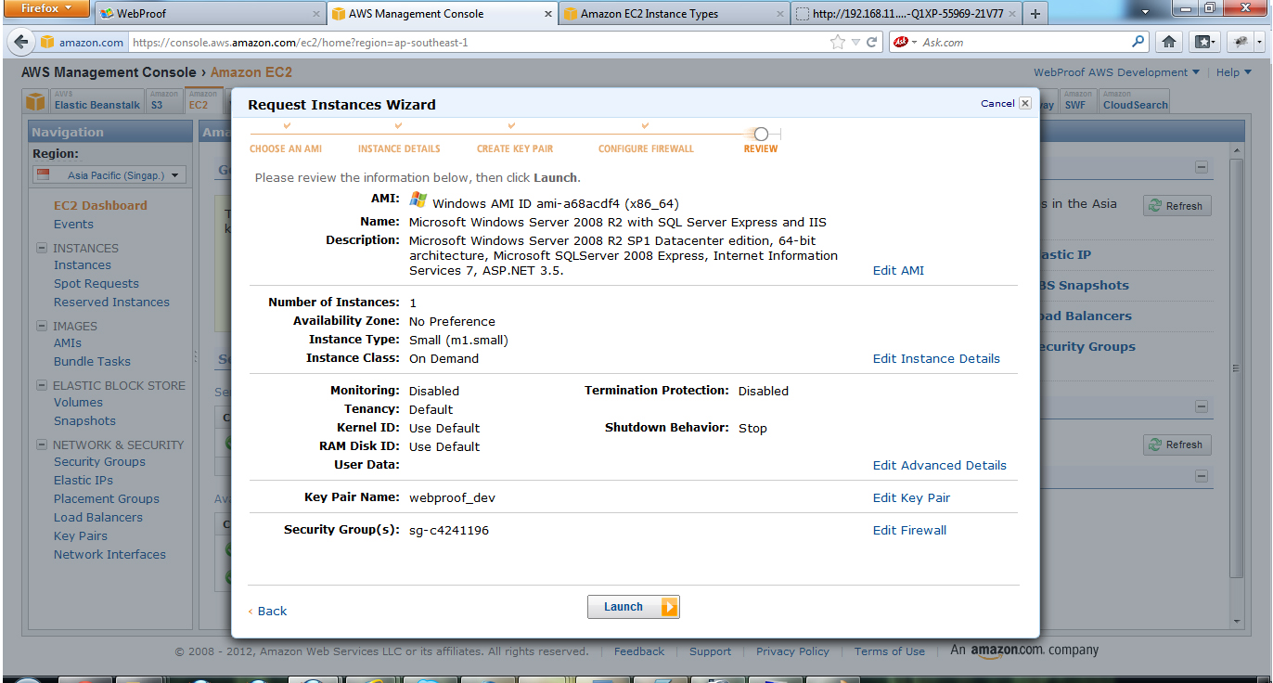

This is final step here you can review the settings and other things with which your instance is going to be launched  , to modify any settings you can click on back link at bottom left side and go back to previous steps .

Finally click the launch button and you are done with your Ec2 instance ! Congratulations !

**Connecting to Ec2 instance :-**

Now you are ready to connect to your ec2 instance and manage it.

Go to amazon ec2 dashboard and click in Instances  in left menu you will see your newly created instance listed in the grid .

Check the check box  shown in instance row and from above instance action menu  select the connect option …

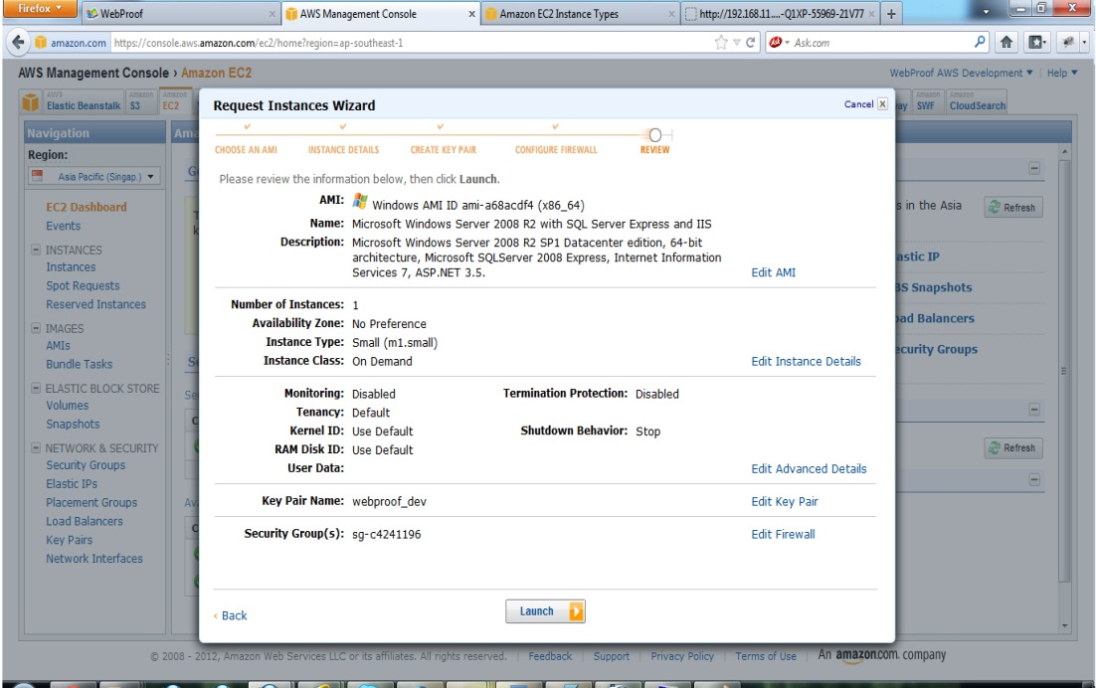

This is final step here you can review the settings and other things with which your instance is going to be launched  , to modify any settings you can click on back link at bottom left side and go back to previous steps .

Finally click the launch button and you are done with your Ec2 instance ! Congratulations !

**Connecting to Ec2 instance :-**

Now you are ready to connect to your ec2 instance and manage it.

Go to amazon ec2 dashboard and click in Instances  in left menu you will see your newly created instance listed in the grid .

Check the check box  shown in instance row and from above instance action menu  select the connect option …

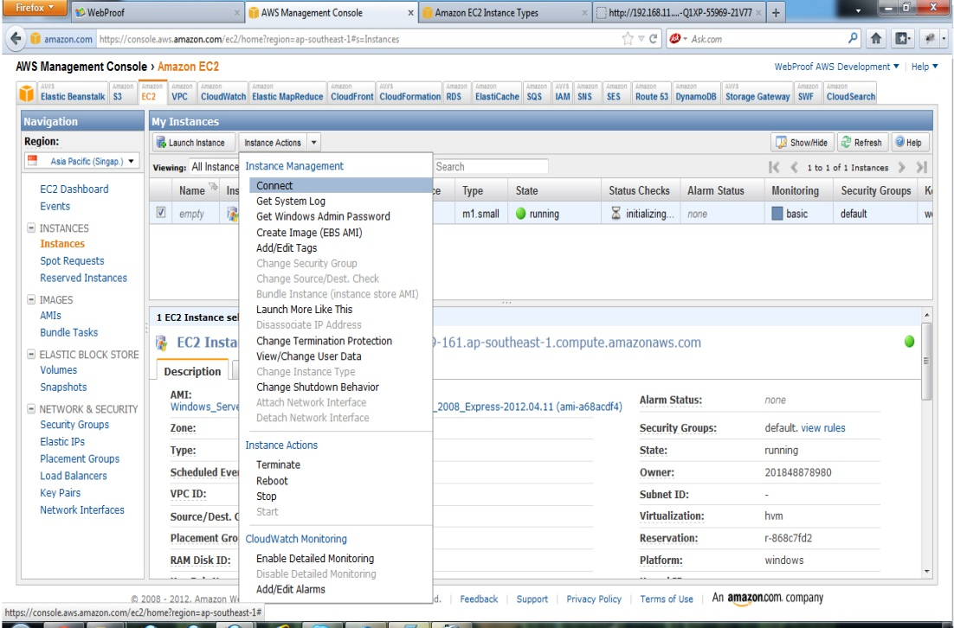

This will open up a  Remote desktop connection window that will have the public DNS ,Username and a link named  Retrieve password  as below :-

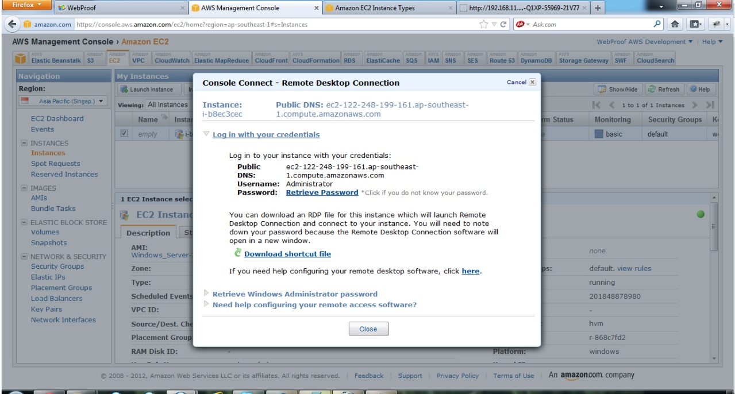

Click on retrieve password link and it will ask you to locate the private file that you have downloaded in above ec2 instance creation process .

Browse and locate that file you saved earlier and click on decrypt button .

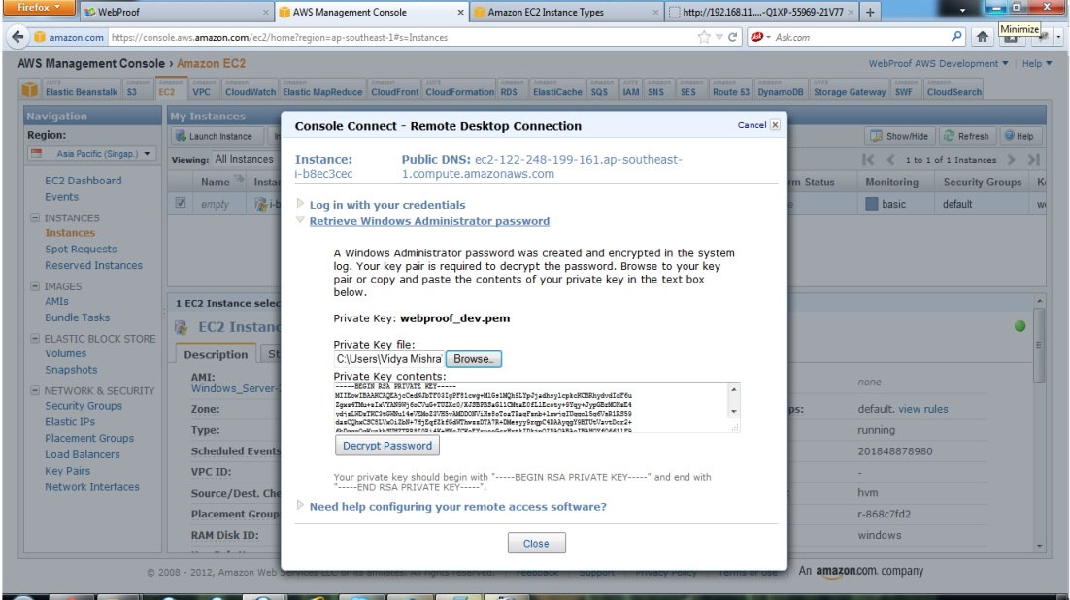

Now you will get the remote desktop window that will have Public DNS , UserName as well as password required to connect to your ec2 instance .

Save these credentials and click to “download shortcut file link” on  remote desktop window that will open up a  open/save window , simply click ok button …

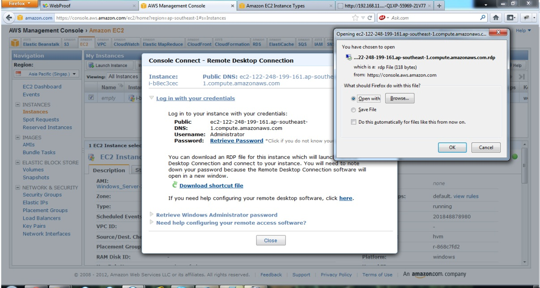

This will open up the windows remote desktop connection window , provide your user name and password as noted earlier and click ok .

Congratulation ! You are now connected to your new Ec2 instance …..

**Modifying the security settings of ec2 :-**

Ec2 instance by default applies lot of restrictions on various works , we can modify the security settings of  ec2 instance to enable features such as RDP access, Remote access to sql server ,

http/https requests to ec2 and so on.

Doing so is very simple .. you need to go to amazon ec2 dashboard  click security group under

Network and Security section in left menu .

You will see a list of security groups appear in grid , select the security group under which your ec2 instance is runing , click the **inboud** tab in the bottom as follow :-

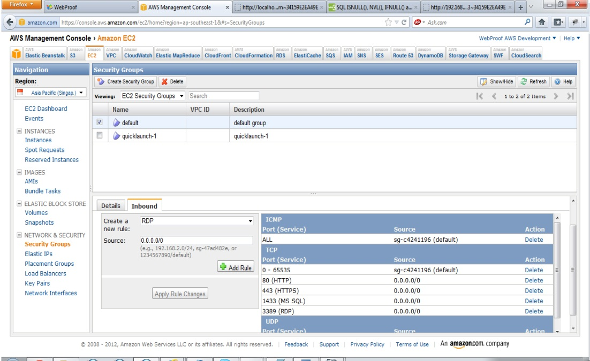

**Extending the default root drive space of ec2 instance :-**

By default a small type ec2 instance has C drive space of 30 GB , that is not enough for the

         a development server having large range of application , so we need to extend the space of Ec2

          root drive and thanks to amazon that provides very simple way to do this  with below steps :-

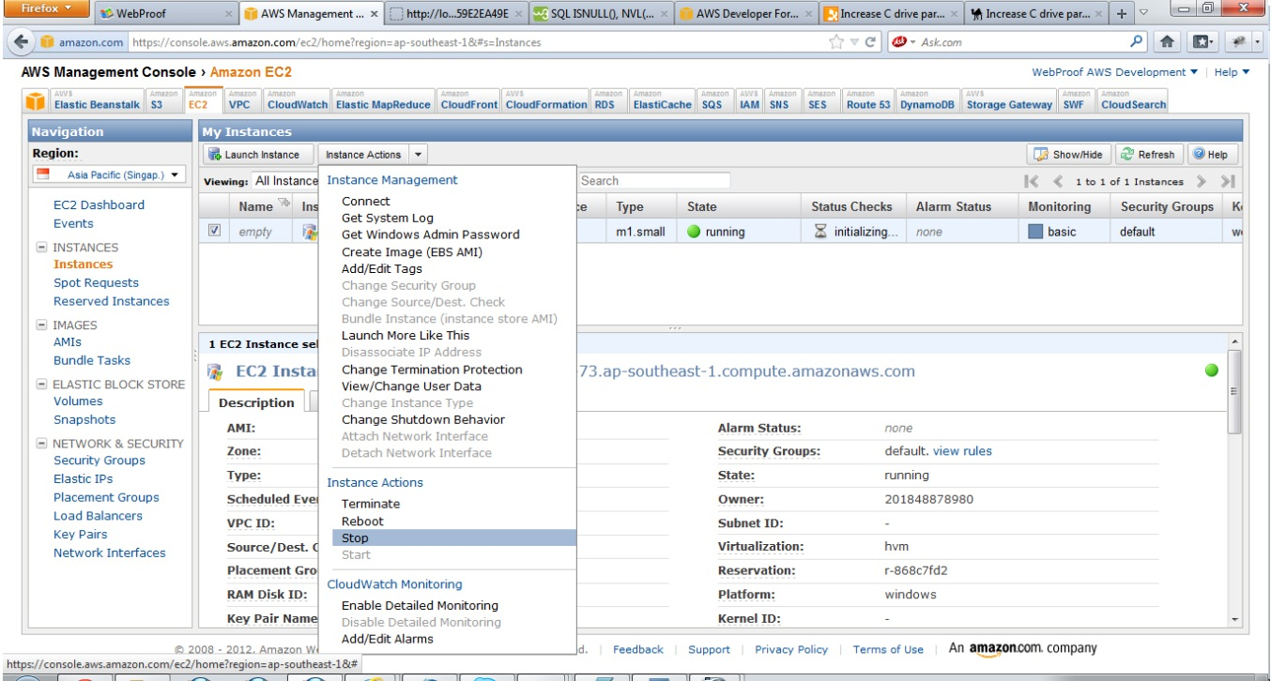

**1**. **Stop the instance**.

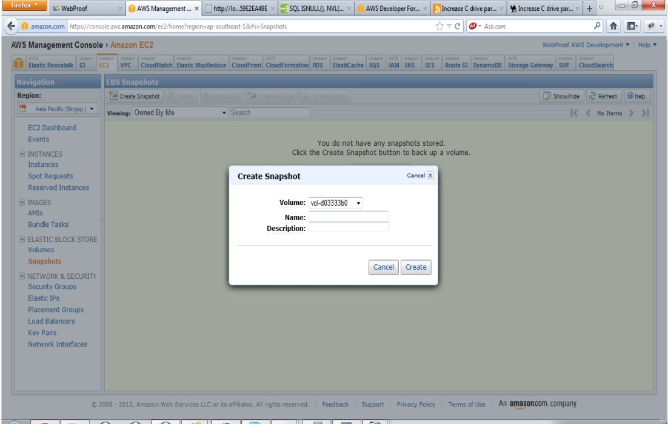

**2. Create the snapshot of the root device**

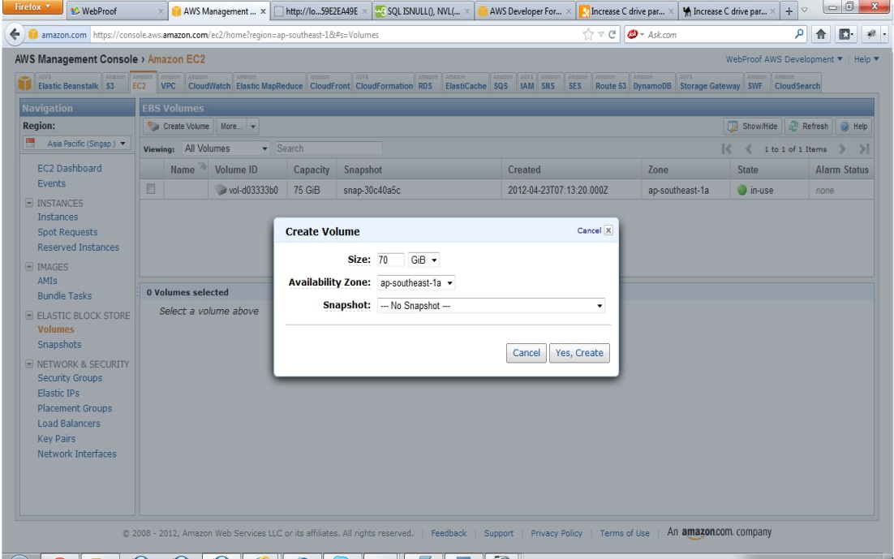

**3.Create a new volume using the snapshot of the root device, but with a larger size.**

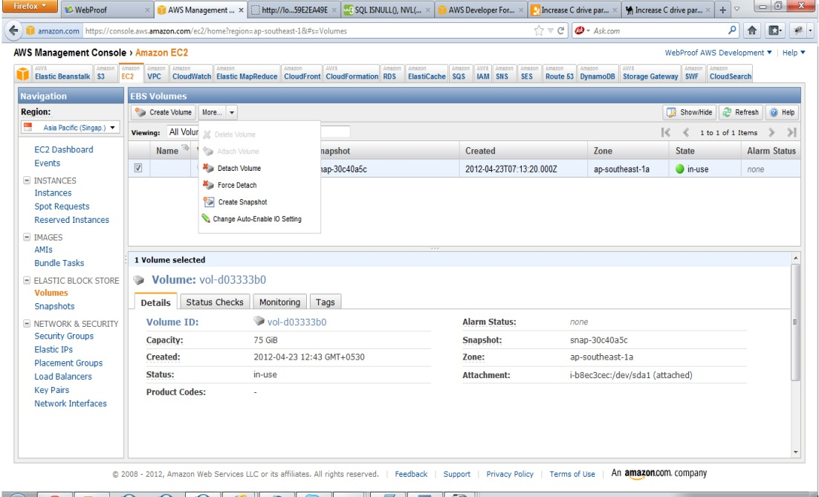

Select the snapshot you have created in earlier step , enter  appropriate  size and click on Yes,Create button.

**4.Attach the new volume to your instance as the root device (/dev/sda1):-**

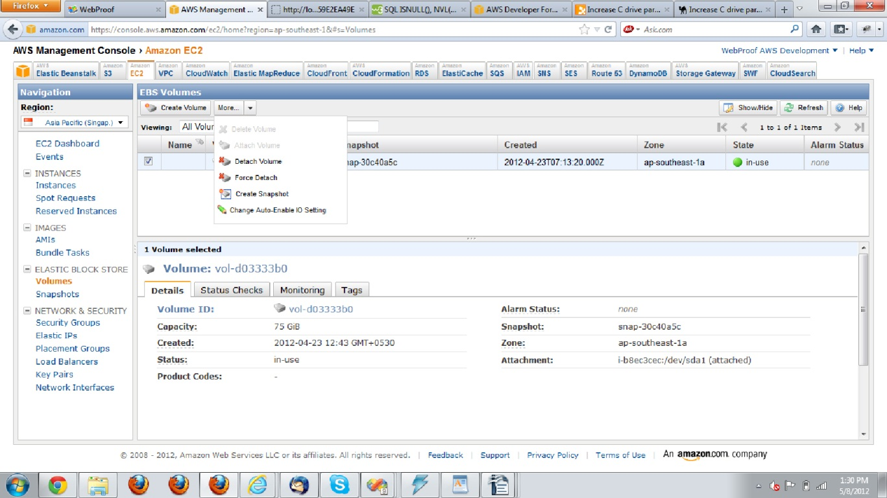

**5. Start instance to make sure it works.**

**6. Go to diskmgmt.msc, right click on C drive and chose extend Volume and complete  the wizard.**